**AWS Cloud Practitioner Essentials**

**EC2 instance** - Elastic Compute Cloud.

These are cloud servers. The elastic relates to the fact it can be expanded/tightened whenever required if configured correctly. Different types of OS can be chosen. They’re pay-as-you-go. Can be hosted in different regions globally. Select Amazon Machine Image (AMI), this is the software. Instance type, this is the hardware. Can configure different storage and network settings and key pairs for SSH to the instance.

**Amazon Elastic Block Store** - EBS volumes can be used as storage for EC2 instances. They can be HDD or SSD, depending on cost vs requirement. Elastic volumes. Backed up using snapshots. They’re replicated in the same Availability Zones for high availability.

**S3 Bucket** - Simple Storage Service. Not associated with any server. Used by simple API function. Store virtually unlimited number of objects. Objects can be files, data streams, DB backups, VM snapshots. Etc. Accessed anytime from anywhere. Highly securable.

**Integrated Services.**

**Application Load Balancer** - Can load balance requests based on the ports being used. This can be done to individual Listeners or to a group of Listeners, known as Target Groups.

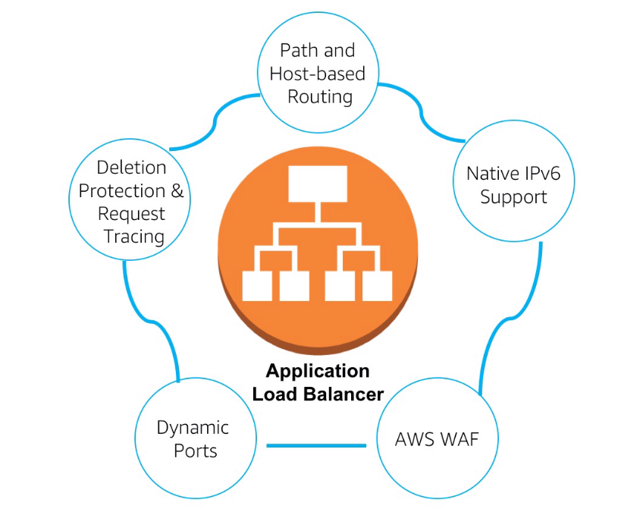

**Auto-Scaling -** this is where VPC and EC2 instances, when configured correctly, are able dynamically scale up or scale down. Scale up for resources. Scale down to keep cost low. This can be configured when “CPU > 65% then add 2x Instances”. AWS will automatically scale to protect CPU so it doesn’t fall over and create down-time for Users.

**AWS Route 53** - This is the AWS DNS. Routes Users to applications within AWS. When instances or applications are spun up the Route 53 updates with an entry for the application allowing Users to route to it. Configure DNS Host zones, then create Record sets. Creates DNS entries and all subdomains here.

**AWS Lambda** - Event driven computing. Use a variety of coding languages, python, C#, NoJS, Java. Can process from S3 bucket or real-time from Kineses. Up to 100 Billions events can be processed each month.

Example 1. When a photo is uploaded it activates a lambda function that processes the document and resizes it to a thumbnail for viewing on a desktop / laptop / mobile.

Example 2. Social media streams are loaded into Kinesis in real-time. A lambda function runs code that will analyse the code and generate hashtag trend data and stores it in DynamoDB. Businesses users can then query the DB to see hashtag trends.

**AWS Elastic Beanstalk -** Platform as a service. Allows for quick deployment of your applications. Can drop code easily and run from the platform. It also reduces management complexity.

Keeps control in your hands - Choose instance type / choose DB type / set and adjust auto scaling / Set automatic updates / access server log files / enable HTTPS on load balancer.

Supports: python, Ruby, Java, PHP, .NET. etc.

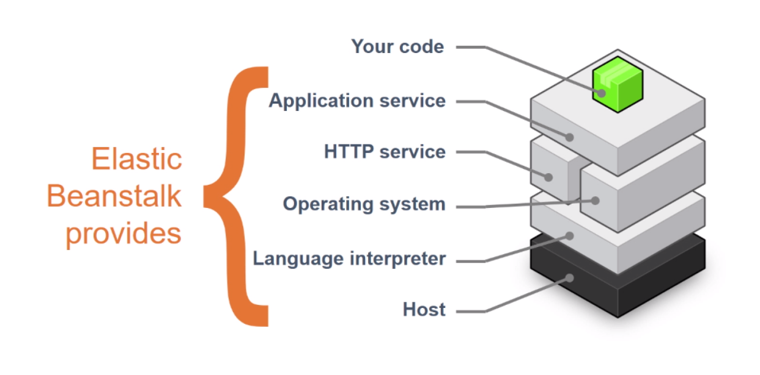

Elastic beanstalk provides all of the underlying platform, as a developer all that is required is to drop the piece of code on top of the platform and it is ready to deploy.

**Amazon Simple Notification Service** - Flexible, fully managed, publisher/subscriber messaging and mobile communication service. Coordinates the delivery of messages to subscribing endpoints and clients.

Easy to set up, operate, and send reliable communications. Decouple and scale microservices , distributed systems and serverless applications.

Example. Create a SNS Topic first and then subscribe email addresses to it. Apply this SNS Topic to an S3 bucket, configure it as desired and add the notification Topic. So whenever something gets deleted or modified it will send an email to all addresses subscribed to the SNS Topic.

**AWS CloudWatch -** monitors the AWS resources and the applications you run in real-time.

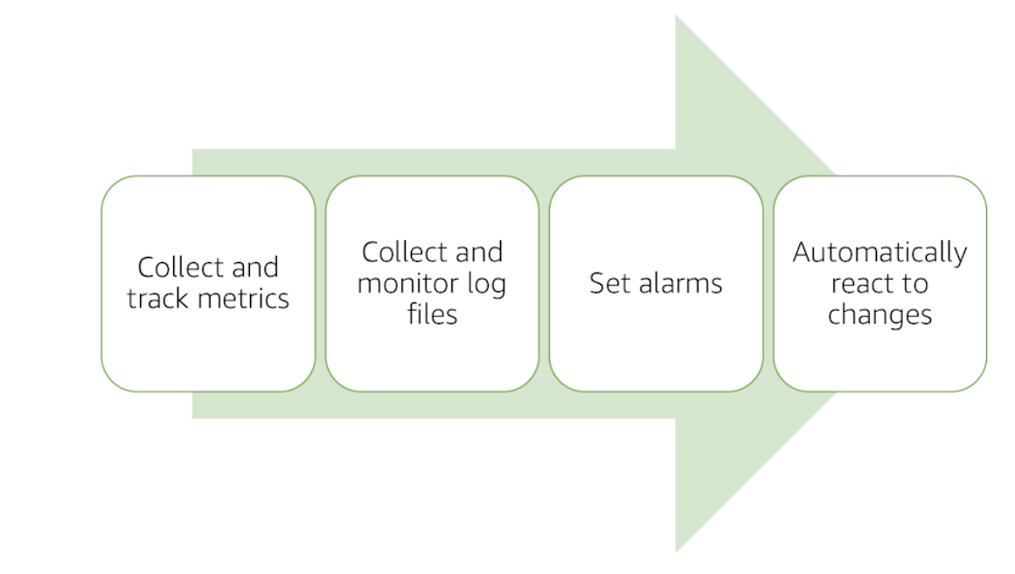

* Respond to state changes in your AWS resources.
* Automatically invoke an AWS Lambda function to update DNS entries when an event notifies that Amazon EC2 instance enters running state.
* Direct specific API records from CloudTrail to a Kinesis stream for detailed analysis of potential Security or Availability risks.
* Take a snapshot of an Amazon EBS volume on schedule.
* Log S3 object level operations using CloudWatch events.

CloudWatch components:

* Metrics - data about the performance about your system.
* Alarms - watches a single metric. EC2 action, auto scaling action, SNS Topic.
* Events - Near real-time stream of system events. If an event occurs then do an action.
* Logs - Monitor and troubleshoot systems and applications using existing log files. Monitor logs for specific phrases / values / patterns.
* Dashboards - Customisable home page in the CloudWatch console to monitor your resources in a single view.

**Amazon CloudFront** - CloudFront is a Content Delivery Network (CDN). Allows developers to cache their content in an AWS instance near their customer-base creating a low latency system.

* Global, growing market
* Secure content at the edge
* Deep integration with key AWS services
* High performance
* Cost effective
* Easy to use

**AWS CloudFormation** - Simplifies the task of repeatedly and predictably creating groups of related resources that power your applications. CloudFormation takes an input template file and creates a stack (VPC, Subnets, DB, S3 bucket).

Stacks are the resources that are generated. They’re a unit of deployment. Possible to create, update and delete stacks. Deleting a stack will delete all of the resources within the stack.

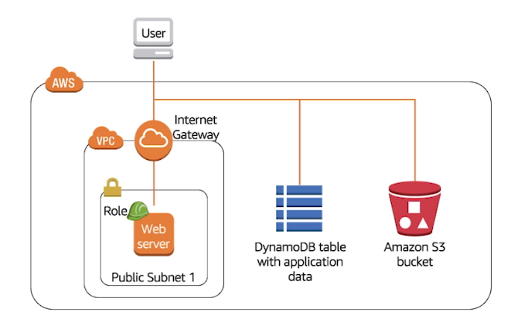

The template is a text file, written in either JSON or YAML. Creating the environment using template files creates a self-documenting environment.

Templates control your infrastructure by code. A separate template might be used for Dev / Security / Network / Test / Prod.

If an error is detected in the template then creation will stop and AWS will roll-back everything that was done so far in the process.

Permissions - The person processing the template must have the required permission level to access all of the resources used in the template.

**AWS Architecture**

**AWS Well-Architected Framework -** The framework is for Customers to assess and improve their architecture, understand how design decisions impact their business, and learn the five pillars and design principles.

Five Pillars:

* **Security**
* **Reliability**
* **Performance efficiency**
* **Cost optimisation**
* **Operational excellence**

Security:

* Identity and Access Management (IAM) - critical to ensure only authorised and authenticated users can access resources.
* Detective Controls - can be used to identify a potential security incident. Integrating auditing controls.
* Infrastructure protection - ensures systems and servers within the environment are protected.
* Data protection - data classification, encryption, data-backup and replication.
* Incident response - respond and mitigate to any security incident.

Security Pillar:Design principles

* Apply security to all layers.
* Enable traceability.
* Apply principle of least privilege.
* Focus on securing the system.
* Automate.

Reliability:

* Recover from infrastructure / service failures
* Apply best practices in:
  + Foundations
  + Change management
  + Failure management
* Anticipate, respond, and prevent failures

Reliability Pillar: Design Principles

* Test recovery procedures
* Automatically recover
* Scale horizontally - replace 1 SPOF server with multiple smaller servers
* Stop guessing capacity - auto-scaling
* Manage change in automation

Performance efficiency:

* Select customisable solutions
* Review to continually innovate - implement new tech when released
* Monitor AWS services
* Consider trade-offs

Performance efficiency: Design Principles

* Democratise advanced technologies - consume new tech as a service
* Go global in minutes - easily deploy globally
* Use a serverless architecture
* Experiment more often
* Have mechanical sympathy

Cost optimisation:

* Use cost-effective resources
* Matching supply with demand
* Increase expenditure awareness
* Optimise over time

Cost optimisation: Design Principles

* Adopt a consumption model
* Measure overall efficiency
* Reduce spending on data centre operations
* Analyse and attribute expenditure
* Use managed services

Operational Excellence:

* Manage and automate changes
* Respond to Events
* Define the standards

**Fault Tolerance and High Availability**

Fault tolerance - the ability for the system to remain operational even if some of the components fail. Built in redundancy of an application’s components.

High availability - ensures that systems are generally functioning and accessible. Downtime is minimised. Minimal human intervention is required. Minimal up-front financial investment.

High availability Service Tools

* Elastic load balancers
  + Distributes incoming traffic
  + Send metrics to CloudWatch
  + Triggers/notifies - high latency / over utilisation
  + Public or private facing
* Elastic IP addresses
  + Are static IP addresses
  + Mask failures
  + Continues to access applications if an instance fails
* Amazon Route 53
  + Authoritize DNS service
  + Simple routing
  + Latency-based routing
  + Health checks
  + DNS failovers
  + Geo-location routing
* Auto-scaling
  + Terminates and launches instances
  + Assists with adjusting or modifying capcity
  + Creates new resources on-demand
* Amazon CloudWatch
  + Distributed statistics gathering system
  + Tracks your metrics of your infrastructure
  + Create and use your own custom metrics
  + Used with auto scaling

Fault Tolerant Tools

* Amazon Simple Queue Service (SQS)
  + Highly reliable distributed messaging service
  + Ensure your queue is always available
* Amazon Simple Storage Service (S3)
  + Stores data across multiple different devices
  + Across multiple different facilities across the region
  + Simple web service - you only pay for what you use
* Amazon Relational DataBase Service (RDS)
  + Offers several features to enhance reliability:
    - Automated backups
    - Snapshots
    - Multi-availability zone deployments

**Web Hosting**

Fast, easy and low-cost.

What is possible to host on AWS: Company website, content management system social media apps, or internal sharepoint site for example.

Deals with usage peaks in a way that is cost efficient. Major and expensive problems for companies. AWS uses on-demand to adjust capacity to meet your needs.

Another advantage is to set up testing, pre-prod, beta, and prob environments is easy. And then switch them off when they’re no longer needed. Much easier and cheaper than building them in real life.

**Security**

**AWS Security**

AWS provides infrastructure designed with security in mind at every stage. Designed for the most secure customer with resilient infrastructure, high security, and strong safeguards.

Continual improvement - rapid innovation. Constantly evolving core security services, such as IAM, logging, monitoring, key management, network segmentation and ddos protection.

Advanced security services from the world’s best security minded people - address real-time emerging risks and meeting needs at a lower organisational cost.

A properly secure environment provides a compliant environment. Meet compliance.

Governance enabled features - additional oversight, security control, central automation.

Network security

* Built-in firewalls - subnets, network segmentation
* Encryption in transit - TLS
* private/dedicated connections - VPN
* Distributed Denial of Service mitigation

Inventory and configuration management

* Deployment tools
* Inventory and configuration tools - track and manage changes over time
* Template definition and management tools - create VMs from template

Access controls and management

* Identity and Access Management (IAM)
* Multi-Factor Authentication (MFA)
* Integration and federation with corporate directories
* Amazon Cognito
* AWS SSO

Monitoring and Logging. Improve security and reduce the risk profile of your environment.

**Shared Responsibility Model**

In AWS it is a shared responsibility to maintain security of the application. The stack is split into levels, some of which AWS are 100% responsible for and other the customer is.

Userdata - All data is encrypted. Users are responsible for Key pairs - AWS has 0 visibility.

Application - User must maintain these up to date.

Guest OS - User chooses this. Their responsibility to patch it.

~~~~~~~~~ AWS has ZERO visibility above this line with an EC2 instance. AWS cannot see the guest OS, has no idea what applications are installed, and has 0 visibility of User data.

Hypervisor - Zen based hypervisor. AWS has improved it for security and performance.

Network - AWS, proprietary network protocols. Secret network for compliance.

Physical - AWS data centers. Top-Secret.

**Identity and Access Management (IAM)**

User / Role / Group

User - a permanent named operator. Could be human or machine.

Group - a collection of Users. Users can belong to many groups and groups can have many users.

Role - in AWS IAM a role is not your permissions. It is an authentication method.

Permissions sit in the Policy Documents. Permissions can be assigned to Users / Groups / Roles.

Example - compromised credentials log in and hold company to ransom. Administrator can remove the link from User to the policy document, then when the user tries to complete any action IAM goes OK. You seem like you're legit, let’s check the policy document…. There is no policy document, action cancelled. All actions are logged in CloudTrail.

**Amazon Inspector**

IT security challenges:

* Complex
* Expensive
* Time consuming - build/configure/maintain
* Difficult to track all the changes in IT environment
* Hard to do effectively

An automated security assessment service from Amazon. Assesses applications for vulnerabilities and deviations from best practice. Helps assess for compliance.

Inspector produces detailed reports security findings and prioritized steps for remediation.

It can be dropped into the development process for DevSecOps. Reduces risk of deploying with vulnerabilities. Increases development agility. Leverages AWS Security expertise.

Inspector allows full transparency into the development which in turn streamlines security compliance testing and auditing ensuring security is foremost, best practices and defined standards.

Enforces security standards.

Example - Inspector will search AWS EC2 instances to see if remote root login is enabled anywhere, this is a big security risk so it will alert the user with recommendation so this can be rectified.

**AWS Shield**

Managed DDoS protection service. Safeguards applications running on AWS. The service provides always on detection and automatic inline mitigations.

Mitigating DDoS attack challenges:

* Complex setup and implementation
* Bandwidth limitations
* Manual intervention
* Time consuming
* Degraded performance
* Expensive

AWS Shield comes in two flavours, Standard or Advanced. Standard provides automatic protections for all AWS customers at no additional charge. Advanced provides higher levels of protection features and benefits, but comes at a cost. Advanced provides access to the AWS DRT (DDoS Response Team) 24/7 team.

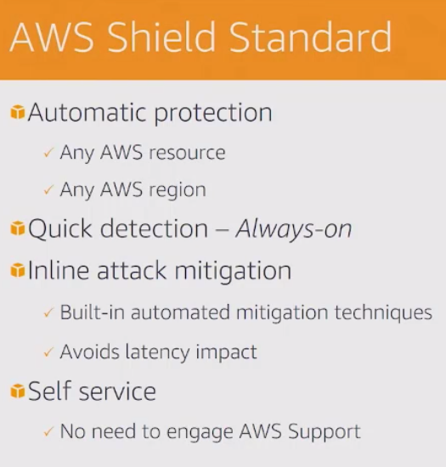 **vs** 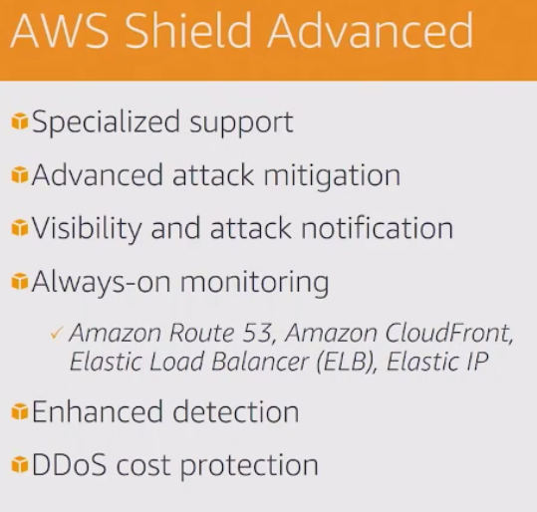

Benefits:

* Cost effective
* Seamless integration and deployment
* Customisable protection

Protecting your DNS - using Amazon Route 53.

Standard - Hosted Zones

Advanced - Attack visibility & DRT Support

CloudFront or Application Load Balancer

Standard - Always-on, scrubs bad traffic. Baselines traffic and watches for anomalies.

Advanced - DRT support, traffic engineering, application layer protection

**AWS Security Compliance**

Shared responsibility:

AWS: Customer: 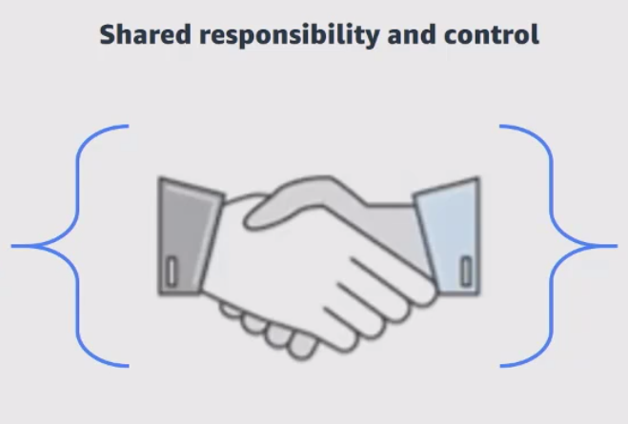

Provide highly secure and Configure IT

controlled platform.

Provide wide array of

features

AWS shares security information by:

* Obtaining industry certifications
* Publishing security and control practices
* Compliance reports

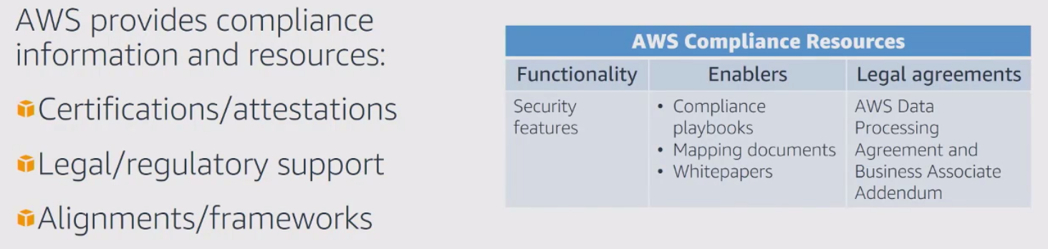

AWS Risk and Compliance programs.

Help customers:

* Document a complete control and governance framework
* Deploy a solutions that meet several industry specific standard

Components of AWS compliance:

* Risk management - Business plan includes risk management, re-evaluated bi-annually. Process:
  + Identify risks
  + Implement appropriate measures
  + Assess various internal/external risks
* Control environment - includes policies, processes and control activities to secure the delivery of AWS service offerings. Supports the operational effectiveness of AWS control framework. Integrates cloud specific controls. Applies leading industry practices.
* Information Security

AWS risk management framework:

* Established framework and policies
* Maintain security policy
* Provide security training
* Perform application security reviews:
  + Confidentiality, integrity, and availability of data
  + Conformance to InfoSec (IS) policy

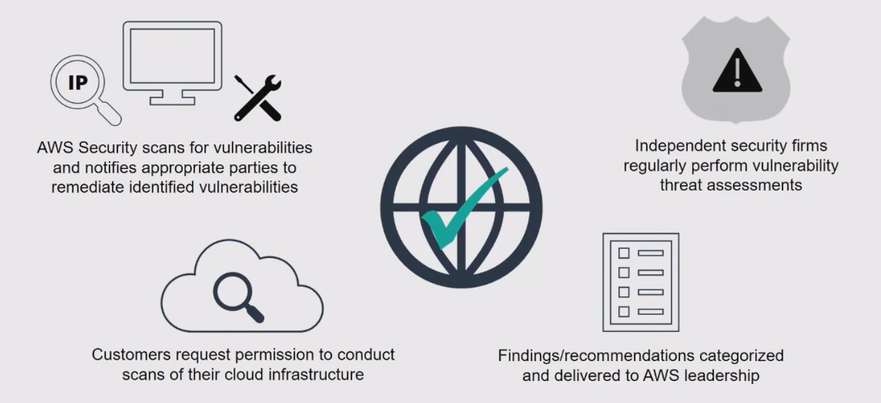

**Pricing and Support**

**Fundamentals of Pricing**

Only pay for the individual services that you need, when you use them, without signing up for long-term contracts. Only pay for what you consume. No termination fees.

Each service - pay for the exact amount of resources that have been used. Pay-as-you-go pricing allows you to easily adapt to changing business needs. Reduces the risk of over-provisioning or running out of capacity.

Reserved capacity instances.

AURI - All upfront. Gets the largest discount.

PURI - Partial upfront. Smaller discount.

NURI - No upfront

AWS Storage.

Tiered pricing in S3, and AWS egress costs.

Putting data in S3 is free.

FREE micro-instance for a year. Trial.

**Pricing Details**

Pay for:

* Compute capacity
* Storage
* Outbound data transfer (aggregated)

No charge for:

* Inbound data transfer

**EC2**

Web service that:

* Provides resizable compute capacity in the cloud
* Allows the configuration of capacity with minimal friction
* Provides complete control
* Charges only for capacity used

Cost factors:

Resources incur charges only when running - clock-second / hourly billing.

Configuration:

* Physical capacity of the instance
* Pricing varies with:
  + AWS Region
  + OS
  + Instance type
  + Instance size

Purchase Types

On-demand instances:

* Compute capacity by the hour and second
* Minimum 60 seconds

Reserved Instances:

* Low or no upfront payment instances reserved
* Discount on hourly charge for that instance

Spot instances:

* Bid for unused AWS EC2 capacity

Other considerations

Number of instances:

* Provision multiple instances to handle peak loads

Load balancing:

* Use Elastic Load Balancing to distribute traffic

Monthly cost based on:

* Hours load balancer runs
* Data load balancer processed

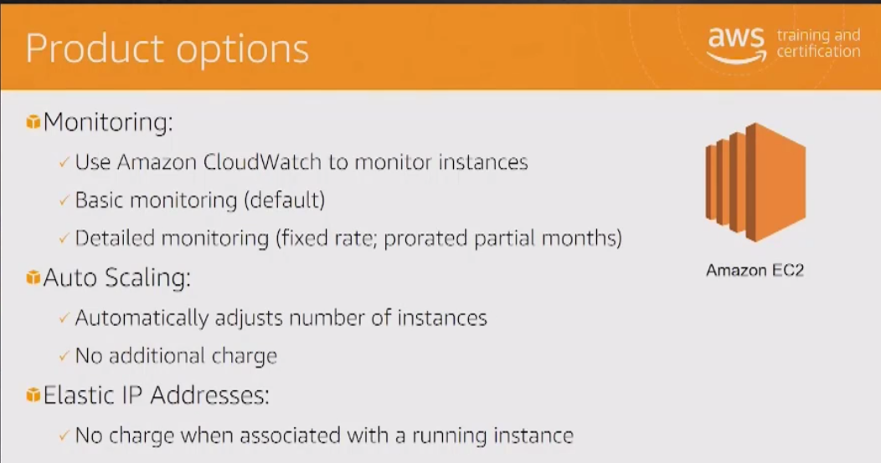

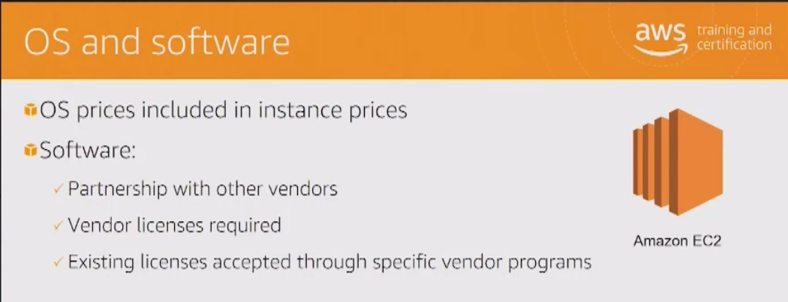

**S3**

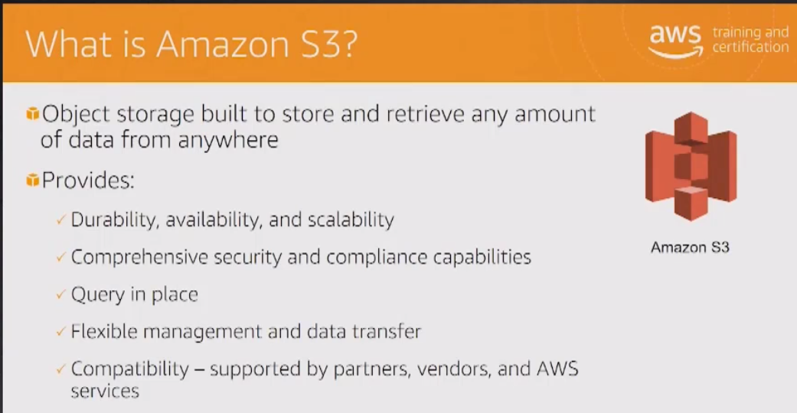

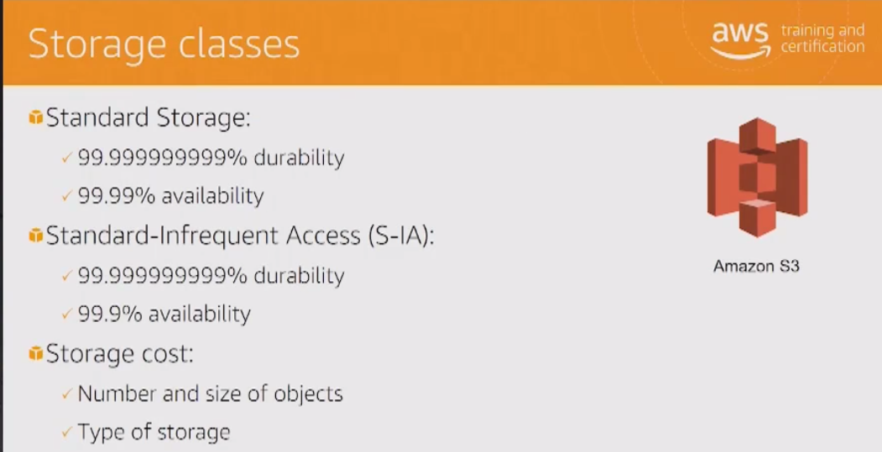

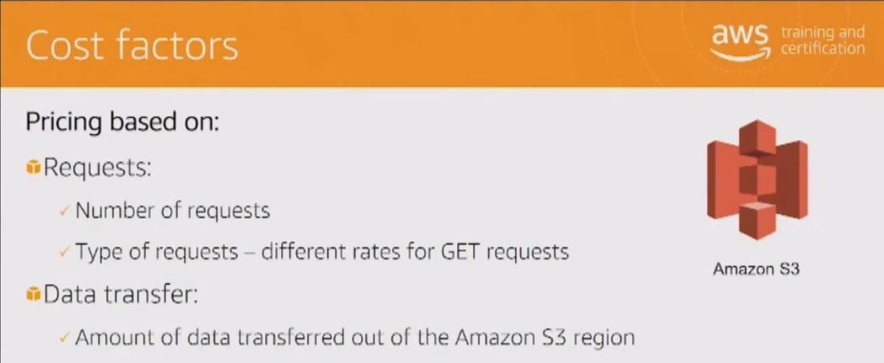

**EBS**

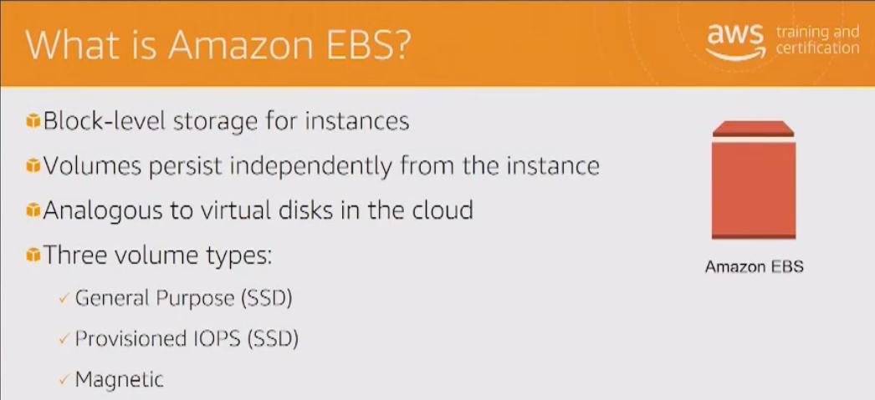

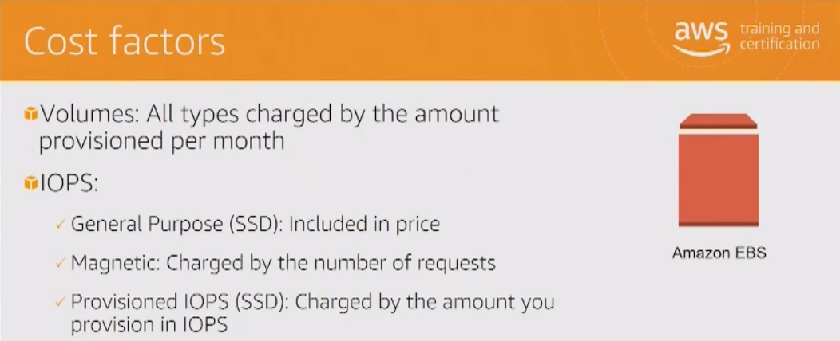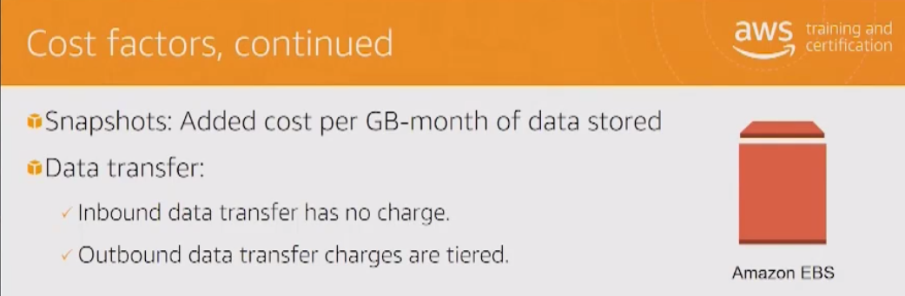

**RDS - Relational Database Service**

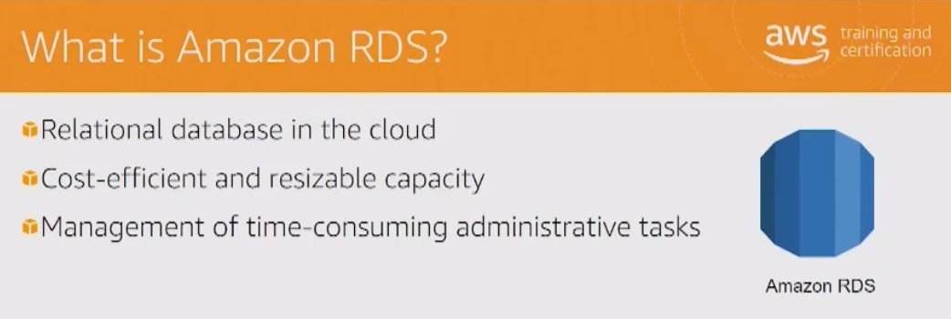

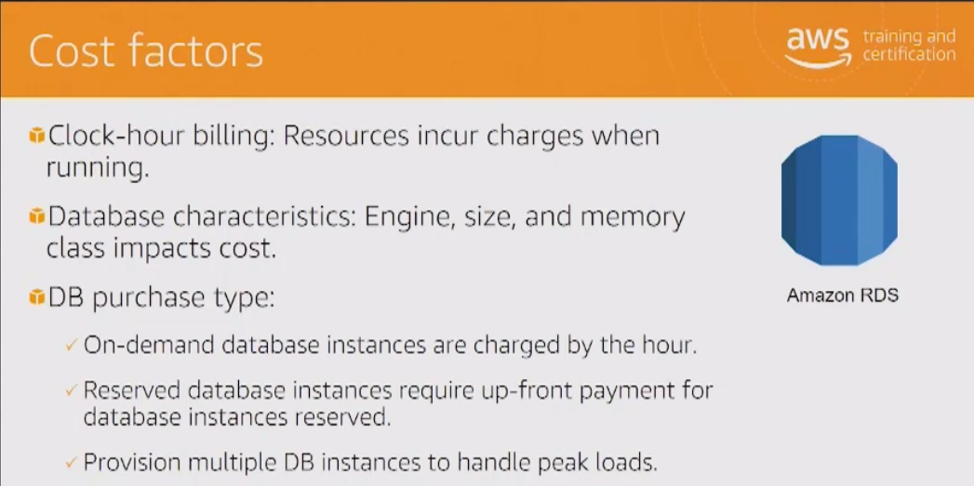

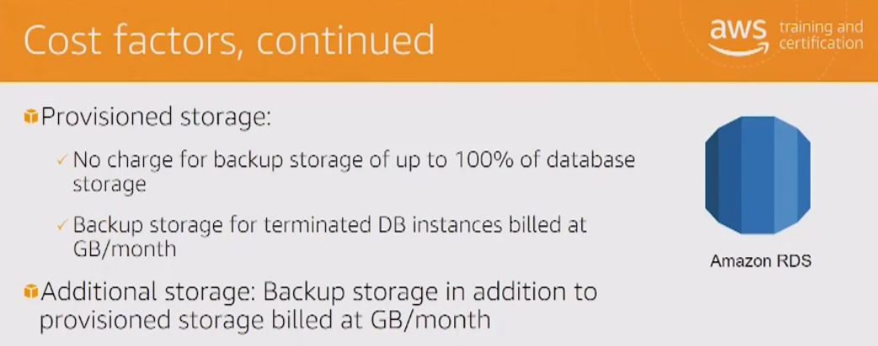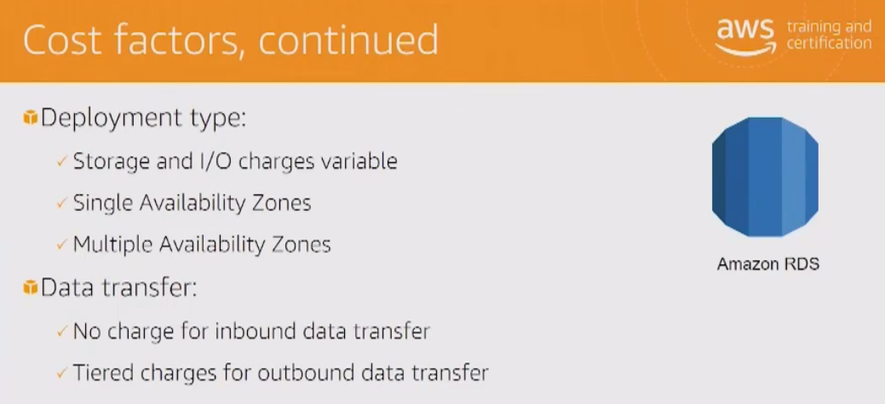

**Amazon CloudFront**

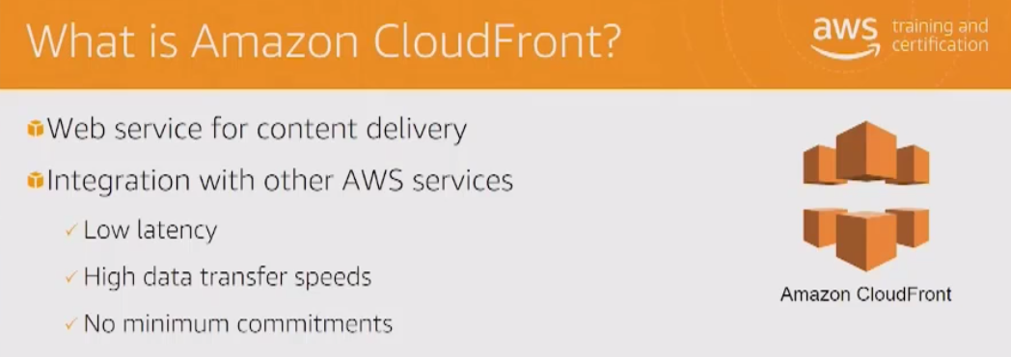

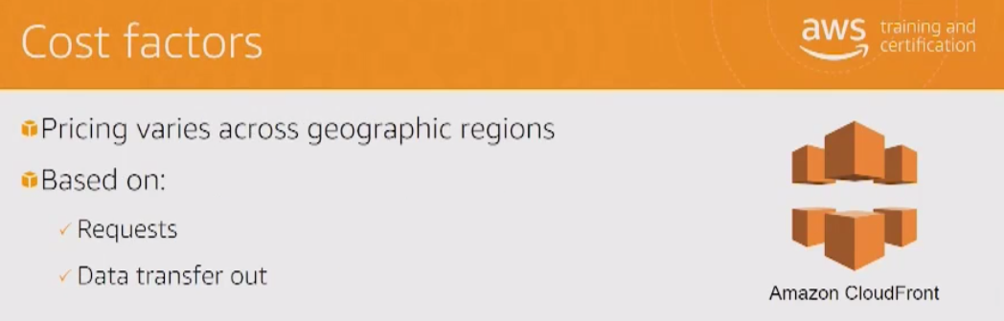

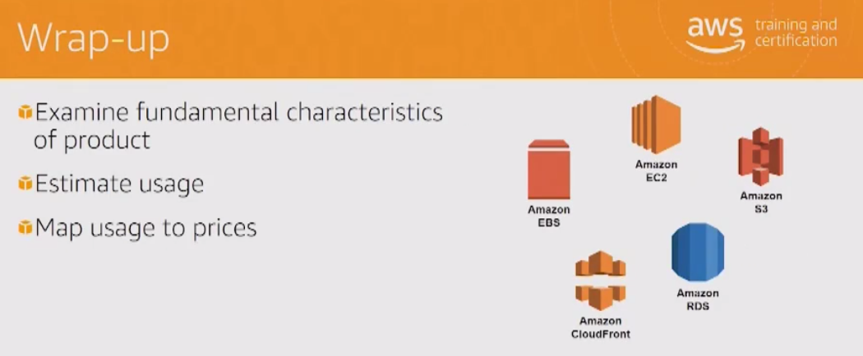

**AWS Trusted Advisor**

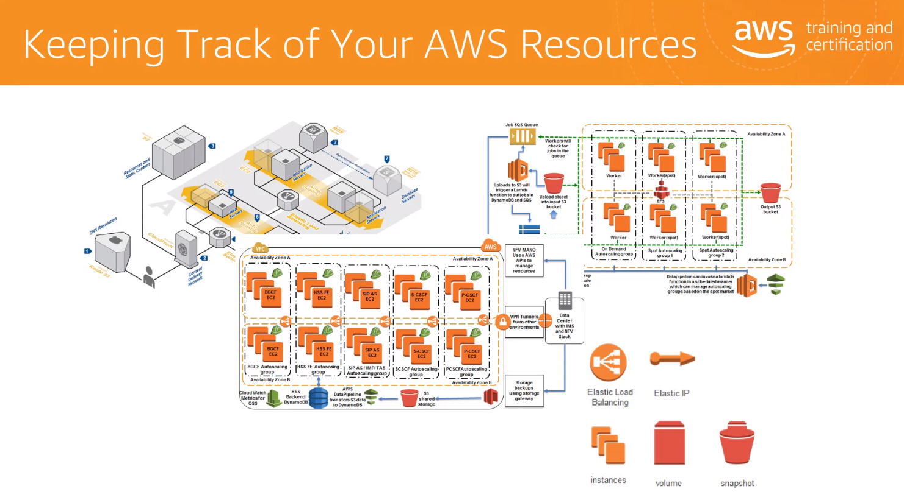

Difficult to keep track of resources as the AWs instance grows.

Cost optimisation

Performance

Security

Fault Tolerance

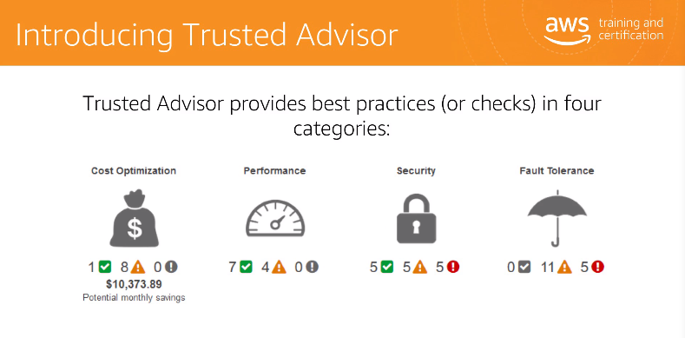

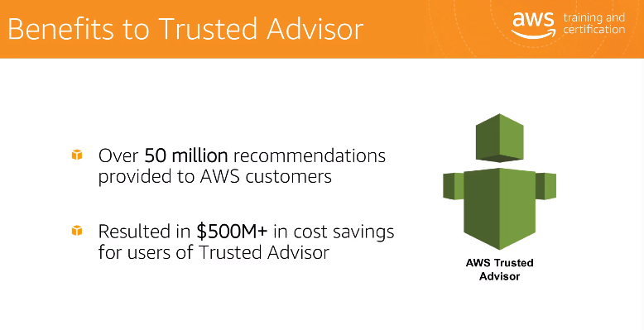

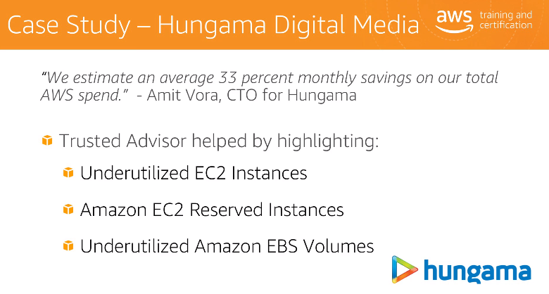

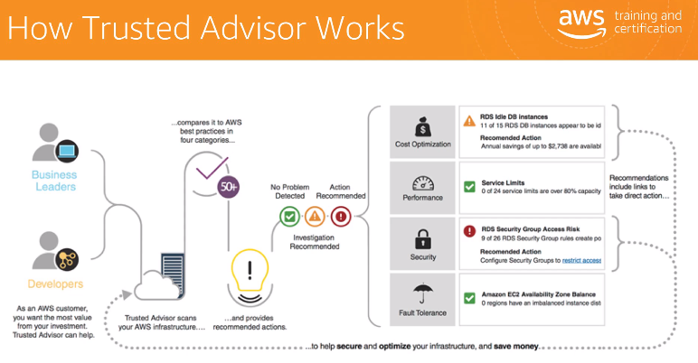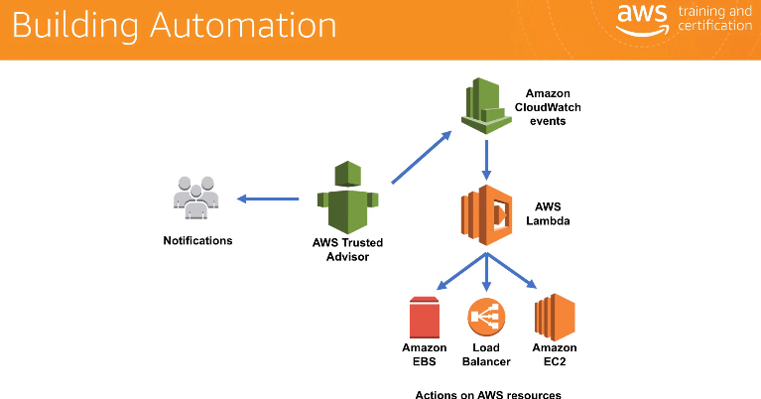

**AWS Support Plans**

Provides an excellent combination of tools/expertise to aid your success.

Support is provided for:

* Experimenting with AWS
* Production use of AWS
* Business critical use of AWS

AWS Support:

Proactive guidance - Technical Account Manager (TAM)

Best Practices - Trusted Advisor

Account assistance - AWS Support Concierge, all non-technical admin support

Support plans:

* Basic support
* Developer
* Business
* Enterprise